BD-in-a-Boxtm: An Agile Framework for BD Success

*Greig C. Fields, MS, CIO, PMP, CSM – October 2016*

## Abstract

BD-in-a-Boxtm Is an affordable, easy to implement easy to use, and Lightweight yet scalable Business development strategic planning, sales operational execution and analysis of business performance results. It is uniquely targeted to drive high quality sales performance through the systematic execution, control and monitoring of BD processes throughout the full BD Lifecycle. In this definition, the BD Lifecycle begins with Strategic Business Planning, Account Planning, Individual Opportunity Cycle Management from Opportunity Identification and Qualification through Opportunity Delivery Exploitation.

The solution consists of a Framework to organize your companies Sales / BD Activities, A toolset to simplify the use of the framework as well as enable access to strategic and tactical information about the sales pipeline anytime anywhere. The system is Web accessible and includes Mobile Applications allowing flexible access and update of Opportunity information from the Android as well as iOS (Apple) platforms. Finally, there are templates already created that support the framework and are integrated with the tools to make BD Analysis, Opportunity Analysis, Review & Approval processes as well as evaluating BD Team and Individual performance a snap. The solution can be easily customized to how you do business with the federal government and supports a robust objective Sales Strategic Planning process. Automated tools collect specific data throughout your sales review period which is analyzed against the strategic plan that is used for real time trend analysis during the period and can be used as input to the next year’s sales strategic planning process. Allowing you to analyze results through automated feedback and update performance parameters based upon the characterization of your specific business and operational approach, thus removing dependence on lagging indicators such as wins and losses and enabling real-time comparison of current pipeline characteristics to planned pipeline characteristics and BD team performance factors as well as trend analysis.

The patented framework is based upon industry best practices and 30 years of professional sales experience. The solution also includes a wide range of consulting services as well as research tools to easily access and integrate information from Federal Information sources such as FDPS, SAM and FedBizOpps.

Implementation of the solution is very flexible usually current pipeline information can be loaded into the system via text file or excel spreadsheet. The Solution can be deployed either on our secured hosted infrastructure or hosted on premise behind your firewall. It easily integrates with MS Active Directory for single sign-on, SharePoint for integration of opportunity information with your back office as well as providing robust linkage with applications such as Sales Force, GovWin and others.

When your company is ready to move from a solely Technology or Service delivery focus, to a Business Development and Sales Driven organization able to win business in new accounts where you have no previous relationships or foot print BD in a Box is THE low cost, easy to implement, easy to use SOLUTION FOR YOU.

## Introduction

## Problem Definition

Organized Follow through on long term opportunities

Disciplined management of the opportunities.

Many small businesses in the Federal space start out with contracts based upon their expertise as well as relationships with specific customers and partners the individual owners worked with previously. The primary focus of the company is operational delivery. Over time many of these companies decide to take their technical expertise and capabilities and go after similar business in other agencies. The primary focus of the company is still operational delivery but there is a desire to focus on growing the business. Most of the leadership in these companies are not experienced Sales or Business Development people so they hire someone to do BD or put together a BD Process. The problem is many of the best BD people are not Sales or BD Operationally focused but more Opportunity engagement focused, which leaves most companies spend 100’s of Thousands of dollars on BD activities without an ability to monitor and control BD expenditures to ensure the long term strategic success of those BD Activities. Typical Questions that need to be answered are:

* Does your company have an opportunity funnel that is targeted to meet its strategic and tactical Sales goals?
* Do you know how much investment will be required to win the new business you are targeting?
* Can you objectively measure the opportunities you are engaging against each other as well as against your growth requirements?
* Can you, in “real time” evaluate your opportunity funnel against your companies’ needs and your strategic plan?
* Can you measure specifically what your cash flow requirements for B&P throughout the year will be?
* Have an objective way to forecast revenue from your current portfolio of opportunities?
* Have a process to review current funnel performance data and use that to refine and increase the accuracy of your strategic planning and goal setting processes?
* Is the only way you can determine BD performance is by the costly method of waiting until the opportunity is won or lost, which can take years of time and cost 10s of Thousands of dollars?
* Do you have an objective way to ensure your BD Team is working the right opportunities in the early stages of the lifecycle as well as real time access to BD performance and trends?
* Does your company have a SOLID Disciplined, Well Defined Opportunity Review Process that drives consistent decision making on opportunity budget and progression approvals, customized to the way you do business?
* Is this information available to you anytime anywhere on any web enabled device?

BD-in-a-Boxtm helps your company ensure that expensive business development and Sales investments yield high performance predictable financial results. It is an approach that ensures you select the right opportunities and have the right staff and processes in place to successfully capture and win targeted opportunities.

Using the Lightweight, inexpensive and easy to use BD-in-a-Boxtm Framework your company can quickly move from a solely Technology or Service delivery focus, TO a Business Development and Sales Driven organization able to win business in accounts where you had no previous relationships or foot print.

## Solution

BD in a box is your single source for Business development strategic planning, sales operational execution and analysis of business performance results. Uniquely targeted to drive high quality sales performance through the systematic execution of the BD Lifecycle. It is a framework based upon industry best practices and 30 years of professional sales experience. This framework covers three specific areas, the Opportunity Lifecycle, Pipeline and Portfolio management and BD Team Performance. The Framework covers the full BD and Sales Lifecycle.

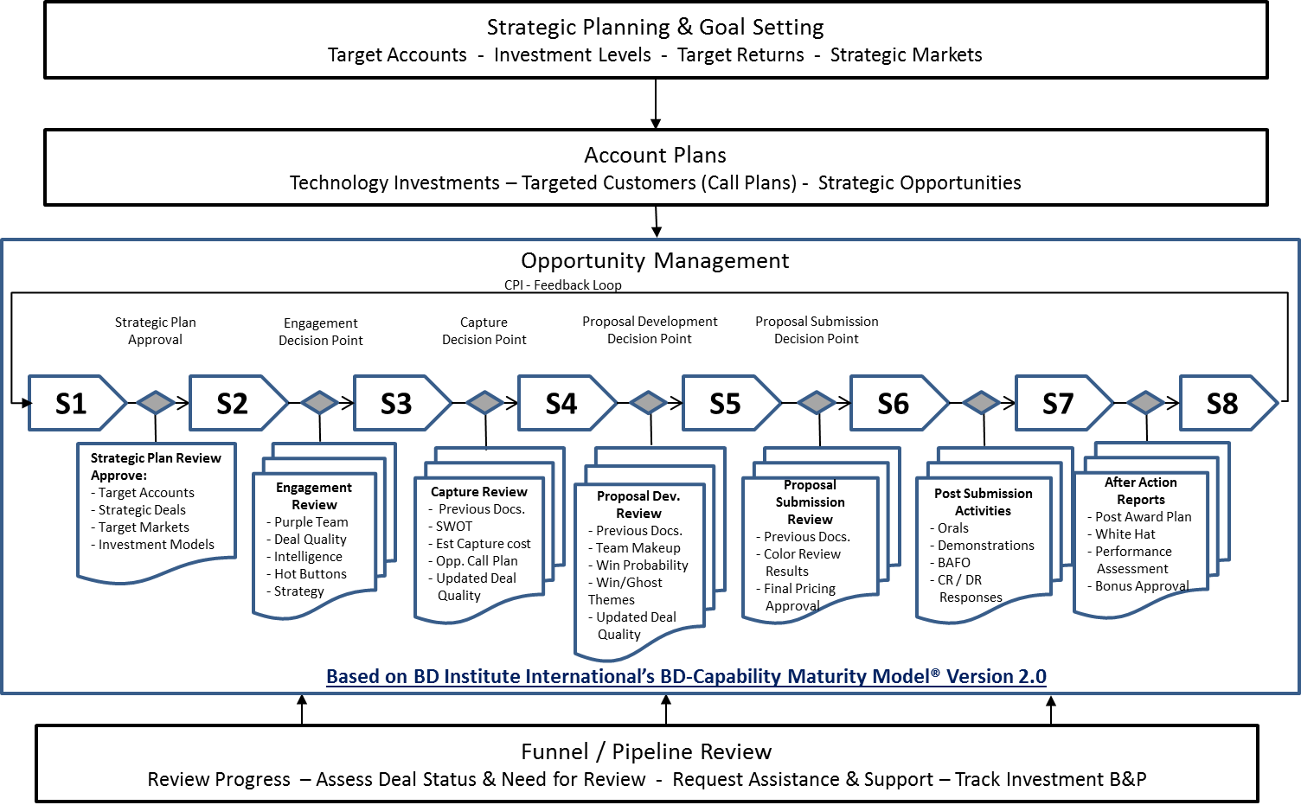

Including Strategic Planning and Goal Setting, Account Planning, The on-going process of Opportunity Management and Regular Funnel Review through Sales Performance Analysis. The frame work takes the standard Model of opportunity capture and breaks it down into 8 Stages easy to use by companies just getting started but comprehensive enough to successfully the support the capture of opportunities spanning multiple years and worth 100’s of millions of dollars. Comprehensive reviews specifically targeted to the particular stage as well as the type of opportunity and whether it’s a Prime or Sub engagement are part of the model and can be customized as needed based upon the needs of the individual company. All Stages have specific activities that are required to be completed before moving to the next stage, including Call Plans, Color Team Reviews, SWOT Analysis etc.

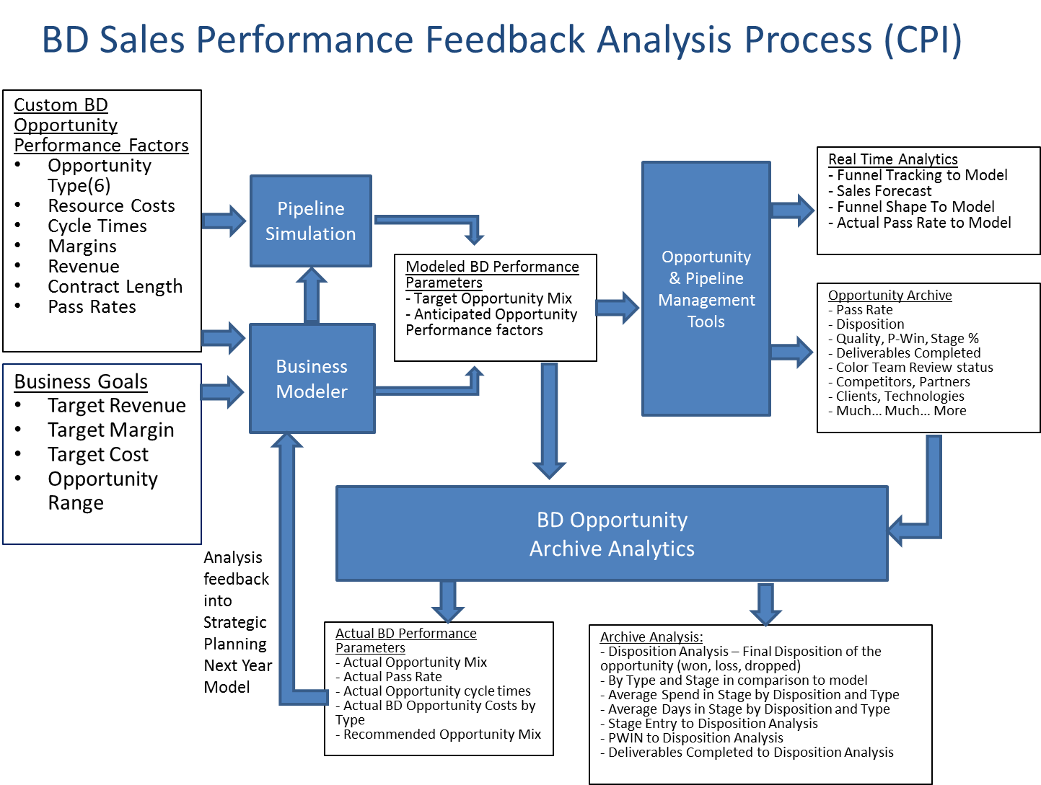Using patented data capture and archival analysis the BD-in-a-Boxtm Framework enables and enhances Sales BD Team Continuous Process Improvement through feedback of performance data and analysis into the Strategic Planning and Goal Setting Process.

It is a set of templates that can be used to capture the important data required to ensure your BD activities are yielding the results you need to execute your strategies to win business. These templates cover all aspects of the BD Lifecycle, from Account Planning, Opportunity Planning, Opportunity Stage reviews, Proposal/Capture Color Team reviews including templates for SWOT Analysis, Call Plan creation and tracking, and Capture of Customer Hot-Buttons that can be used to develop Proposal strategies, Win-Theme and Ghost Theme creation. Finally, it is a toolset that brings the framework and templates together in a automated manageable form that reduces administrative effort. It enables real time, leading indicative analysis of individual opportunities, BD Pipeline and BD Team performance and provides anticipated results based upon parameters customized specifically to the 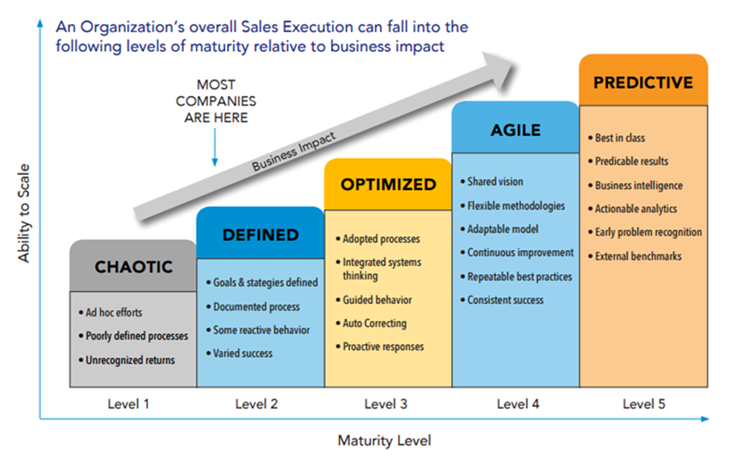way that you do business.

We recognize that Sales organizations vary widely in where they are from a, strategic planning, sales processes, tool sets, and measurements standpoint. We have designed BD-in-a-Box with this in mind, using the **BD Institute International’s Business Development Capability Maturity Model (BD-CMM) Version 2.**0 as a guideline to ensure we have the linkages in place to ensure the organizations success.

No matter where your organization is from a sales maturity standpoint BD in a Box can be easily implemented and is structured to help the organization move to higher levels of Sales and Business Development maturity, and execution. Whether your pipeline consists of a text or spreadsheet or you have more sophisticated tools in place such as Sales Force or GovWin BD-in-a-Box has integration tools that accelerate the process of getting your pipeline / funnel up and running with the framework and tools. It also allows for continued integration and information sharing with CRM, proposal management, financial management tools as well as Information Source providers. AS the organization matures more of the capabilities of BD-in-a-Box can be utilized to easily support implementation of the increasing practice and process required at each level.

Concepts in the BD-in-a-Box Framework:

The framework Characterizes Opportunities based upon three customizable dimensions things:

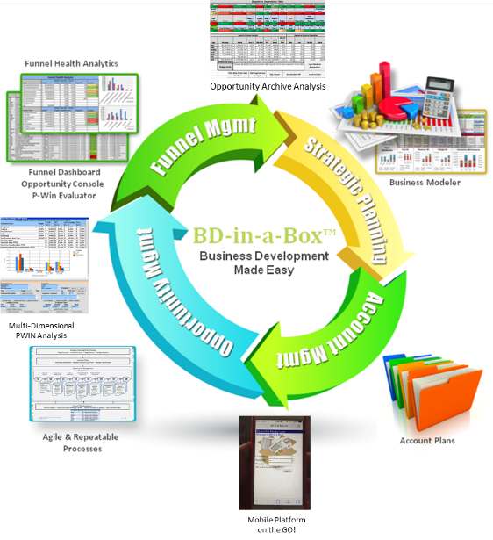1. Opportunity Stages

2. Stage Progression

3. Opportunity Types

**Opportunity Stages**

The Framework Defines 8 Opportunity Stages, each with entry and exit reviews as well as specific deliverable required at the stage based upon the opportunity type. The Stages are:

Stage 01- Understand Customer – Where activities associated with execution of the Account Plan’s procurement identification process take place.

Stage 02 – Validate Opportunity – At this stage Procurements which have been identified are validated with the customer to determine their chance of going through the full acquisition lifecycle.

Stage 03 – Qualify Opportunity – At this stage the characteristics of the procurements are tested against the corporation’s opportunity qualification standards and if found to meet those requirements as well as the requirements of the current pipeline they are engaged.

Stage 04 – Develop Solution – At this stage fully qualified opportunities go through the capture process where the solution required to meet the anticipated customer specifications or requirements is developed including identification of required partners, prime sub roles, and integration activities take place.

Stage 05 – Propose Solution – The opportunity moves into this stage when the customer releases an acquisition document requesting a proposal. All activities associated with the development of the physical proposal response happen during this stage.

Stage 06 – Negotiate and Close – The Opportunity moves to this stage when the proposal is delivered to the potential customer and continues until the award is announced.

Stage 07 – Won & Deploy – This Stage includes all transition activities required until full acceptance activities are completed and the operational mode of the contract begins.

Stage 08 – Won & Expand - This Stage concerns all BD activities associated with contracts that have been won including finding new opportunities in the customer base as well as expanding the scope of the current contract to add additional business.

**Opportunity Types**

There are 6 opportunity types available for use in BD-in-a-Box. These are all customizable based upon the specific needs of the sales organization, industry and market segment. They are characterized in the following ways:

* Opportunity Financials - Average Revenue, Average Margin
* Opportunity B&P Cost - The number and types of Resources Required over time at each of the opportunity stages.
* Opportunity Horizon - The estimated length of time the opportunity spends at each stage.

**Stage Progression** – This is the estimated percentage of opportunities that are anticipated progress from one stage to the next.

There is a special opportunity type IDIQ that is available in the system that is used to expand the market place available to find opportunities it has a B&P cost but has no revenue or margin value of its own.

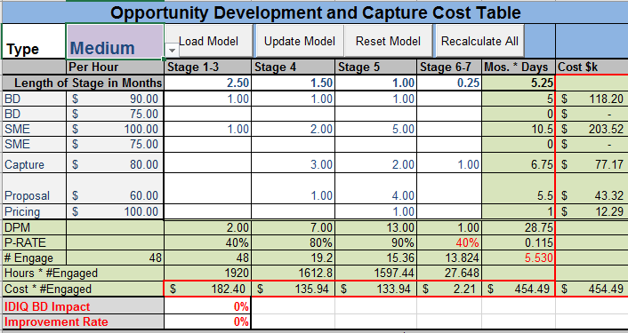

The default approach is to use a configuration based upon opportunity size and complexity the table bellow lists some of the standard characteristics for each standard opportunity type.

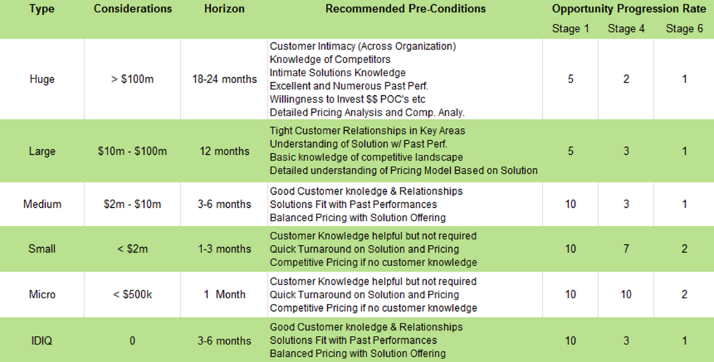

## Modeling and Simulation

Next these customized parameters are used to help determine the best investment models to maximized company goals. These opportunity characteristics that are used in a mathematical model to assess various scenarios. The basic scenarios are:

1. Based upon a Target Revenue provide the best number and mix of opportunity types limiting B&P Cost
2. Based upon a Target Margin provide the best number and mix of opportunity types limiting B&P Cost
3. Based upon a Target B&P provide the best number and mix of opportunity types Maximizing Revenue.
4. 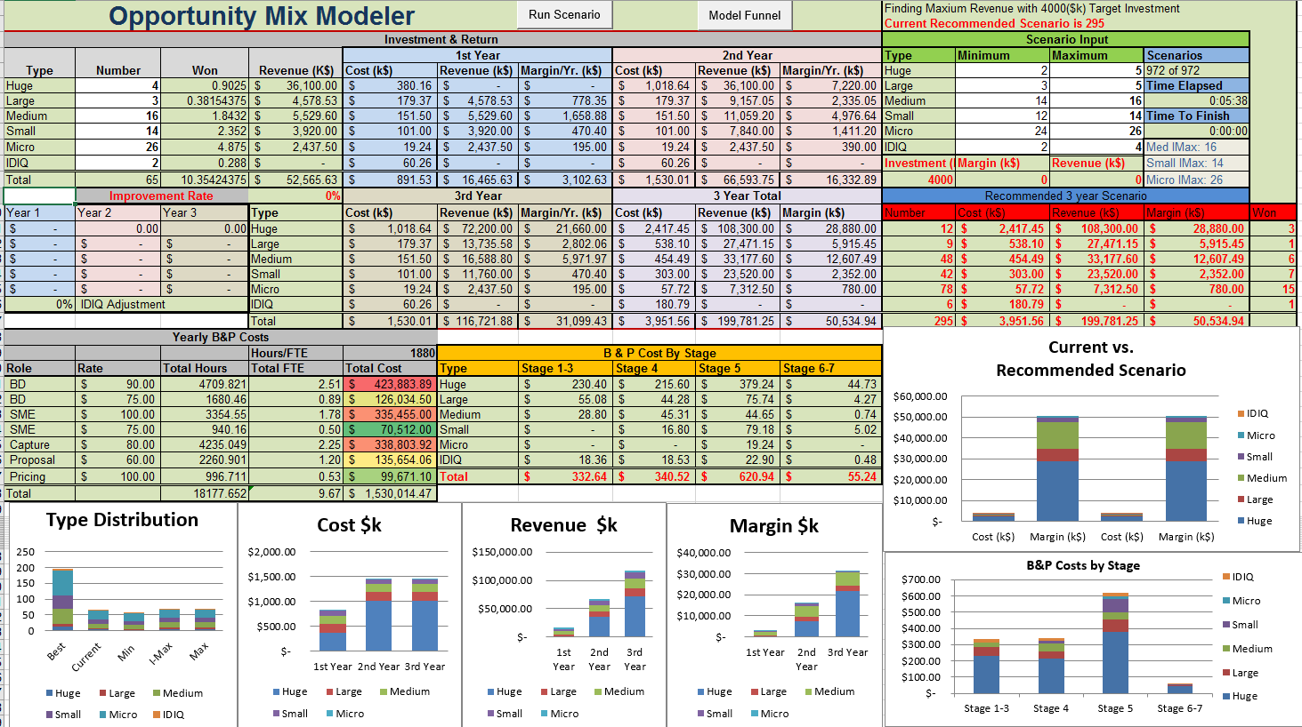Based upon a Target B&P provide the best number and mix of opportunity types Maximizing Margin.

These 3-year mathematical models use the opportunity type and progression data find the mathematically most optimal mix of opportunity types and sizes to best meet the scenario’s goals.

Once the optimal mix of opportunities in the scenario has been determined a Simulation can be run using that through the use of an interactive gate based probabilistic opportunity progression model algorithm simulates the weekly B&P Costs as well as Margin Return and Contract Award Dollars over the 3 year modeling period. This simulation will identify cash flow spikes and can also help determine where opportunity bottlenecks may occur during the period. 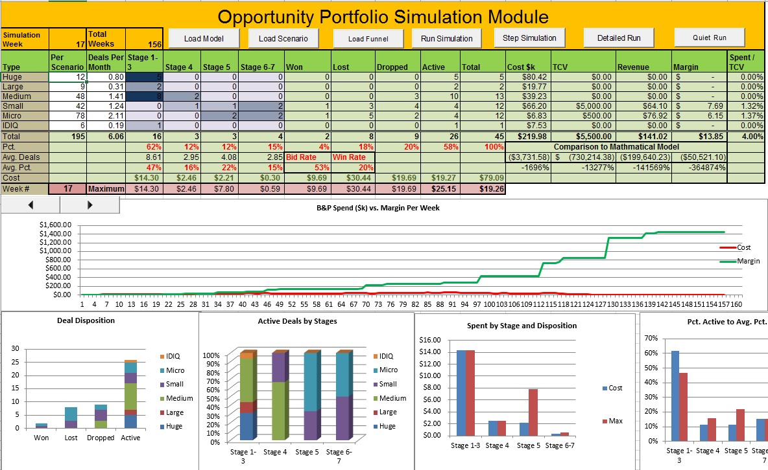 Adjustments can be made at this to finalize the strategic pipeline configuration model. This model is saved in a file and uploaded into the on-line tools that are used to track opportunities throughout the lifecycle. The configuration parameters can be confirmed using Administrative Management tab on the Web Tool.

## Opportunity Management, Control and Monitoring

Deal Health & Quality

Deal Quality is a well known concept where opportunities are assessed based upon a set of standardized parameters to determine their viability and suitability to included in the opportunity pipeline. BD-in-a-Box takes this to the next level by asking different questions in each of the question areas based upon the opportunity stage. The Opportunity quality dimensions are:

* Customer Phase
* Stage Readiness
* Customer Buying Position
* 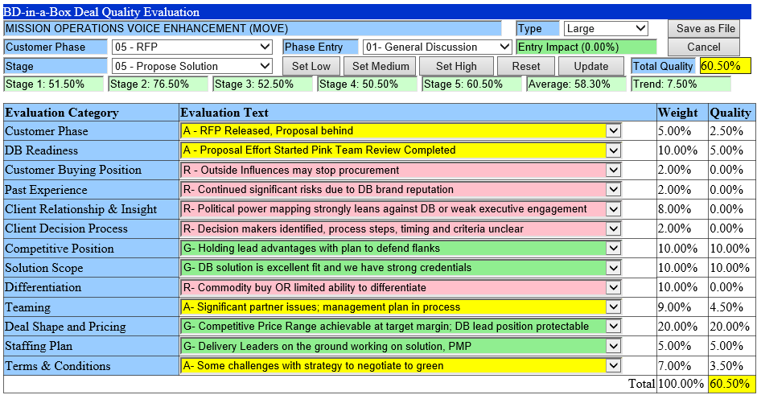Past Experience
* Client Relationship & Insight
* Client Decision Process
* Competitive Position
* Solution Scope
* Differentiation
* Teaming
* Deal Shape and Pricing
* Staffing Plan
* Terms & Conditions

Further the weight of the dimension changes at each opportunity stage so that items such as Deal Shape and Pricing which are critical to the proposal process become progressively more important and Past Experience used to determine and qualify an opportunity in the earlier stages becomes less important. This allows for a consistent leveling of the quality across each stage so that a 60% threshold can be set for all opportunities in the pipeline.

Win Probability Analysis

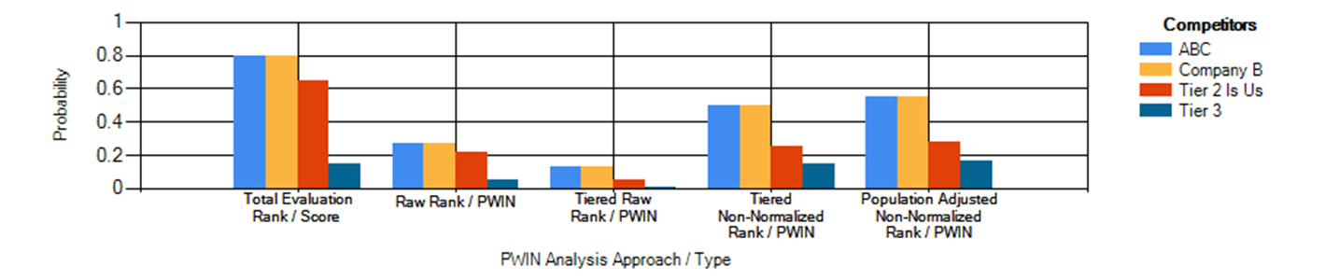Also included is an integrated multi result P-Win model including Population Adjusted, normalized and non-normalized raw models. There are tools that allow for real time analysis of Pipeline content and how that tracks to targets set during strategic planning, tying together deal quality and P-Win averages and trends as they progress through their individual lifecycles to numbers and types of these opportunities their revenue and how that compares with what was anticipated through the modeling process.

**P-Win Tiers**

Tier’s allow for a more object analysis by segmenting possible competitors into Tier’s based upon an estimation of the probability of one of the competitors in that tier being the eventual winner. So Tier 1 might have an estimated probability of 70% that one of those teams will be the eventual winner while Tier 2’s estimate might be 40%, and Tier 3 is a catch all which lists a count of the “unknown” vendors and the chance of a dark horse winning the business.

**P-Win Types**

* Raw PWIN takes evaluation criteria results and associates a probability for each offeror based upon the value relative to the total scoring of all evaluated offerors.
* Tiered Raw PWIN evaluates each offeror in each tier and calculates their value based upon their proportion of points to all evaluated offers in that tier and allocates value based assigning an identical portion of the stated confidence percentage for that Tier.
* Raw Non-Normalized Tired PWIN evaluates each offeror in a tier
* Tiered Non-Normalized P-WIN takes the value of the offeror with the highest evaluation in each tier and associates average difference approach
* Population Adjusted Tiered Non-Normalized P-Win, takes the Tiered Non-Normalized approach amount times the delta of the tiered probability the formula:

(Range between evaluations)

* (delta between evaluation and average of all evaluations)

* (delta between confidence factor and 100%)

+ the Confidence Factor)

Results in:

* ((max(e)-min(e))x(e-av)x(1-c))+c

Where

* e = Raw Evaluation based upon Criteria ,
* av = average of all raw criteria evaluations
* c = confidence factor for each tier
* min(e) = minimum evaluation in population
* max(e) = maximum evaluation in population

Error Checking and Heuristics

Opportunities are evaluated using an automated system with industry best practice heuristics to identify errors (bad data) for instance an RFP Date that occurs after the Proposal Due Date, Warnings such as RFP Due in 7 days and Opportunity is Still at Validation stage” and Informational errors such as “opportunity type and revenue miss-match”.

|  |  |  |
| --- | --- | --- |
| Error Definitions Table | | |
| Error Types | Definition | Example |
| Error | Characteristics in an opportunity that identify it as having known incorrect data or classification | * RFP Date is After Close Date * Closed Date has passed and Not at Stage 6 Negotiate & Close or higher |
| Warning | Characteristics in an opportunity that identify it as possibly having bad data or close to missing a critical deadline | * RFP is in 30 Days on a Large Opportunity and Not at Stage 4 Develop Solution or higher * Amount of an opportunity does not match the Amount Range for the type |
| Informational | Characteristics in an opportunity that may indicate a need to address an issue | * No Entry for Prime / Sub or TBD |

Action Items

As mentioned previously one of the principle causes of lost opportunities is lack of follow up. BD-in-a-Box addresses this with action items. Specific actions on each opportunity are tracked and are time bound to ensure that opportunity information is kept current and that the specific activities, reviews and approvals take place in a disciplined manner that drives continuous success. The action items have a description, responsible party, a due date and a location for comments and status on the progress. Action Items that are due within 7 days are highlighted as pending and actions that are not completed where the due date has past are of course highlighted as overdue

.

Solution Development and Gate Reviews

Strategic Development steps are key in the BD process to obtaining the information necessary while you are still able to directly access the end user client as well as acquisition people. To do this the tool enables the systematic capture of strategic information in an organized manner.

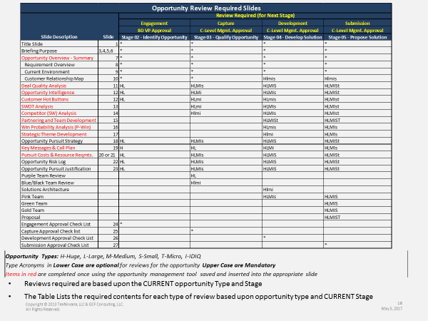The framework outlines not only what is necessary but at which phase of the process it should be started and completed. This Table outlines the list of standard deliverables required during an opportunity lifecycle. Note that the framework takes into account the size and complexity of an opportunity and adjusts the requirement for specific opportunity deliverables.

These deliverables are also captured in the tools so that the need for redundant creation of information for approval and color team reviews is substantially reduced in fact as the organization matures information can be shared directly out of the tool at any time and in small or larger forums. Call Plan, Intelligence, SWOT Analysis, Competitive Analysis, Win Themes, Ghost Themes, Requirements, Current State Environment and more. All organized and integrated in a manner that easily allows for movement of information required at multiple stages without recreation of data.

Gate Reviews & Stage Completion

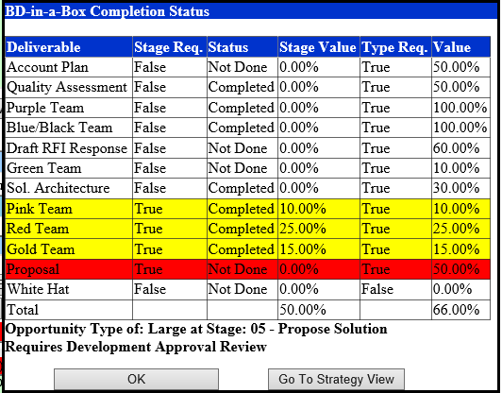Consistency in the review process ensures not only that the deals you do engage are winnable it also ensures that when necessary you can easily decide between opportunities where resource constraints may limit the ability to bid both. Reviews are also critical to ensure that before you move from stage to stage and spend money on an opportunity that all parties agree on moving forward as well as how much to invest going forward. Templates that capture exactly the right information as well as checklists to drive the discussion towards the right factors to use to determine in a quantitative manner whether to move forward.

* Engagement Reviews - Approval to Engage in the process of Validating and Qualifying the opportunity.
* Capture Review – Approval to move into the process of solution development, partner identification for the opportunity
* Proposal Development – Approval to develop the proposal based upon a specific requirement available from the client (RFP, TORP etc.)
* Submission Reviews – Approval by business owners to submit the proposal and pricing information

Each of these has associated checklists that ensure the right information is available and the right questions are asked to make a solid decision on whether to move forward.

Integration with Federal Information Sites

With just a single click add and track opportunities from Federal Government Opportunity Sites such as FedBizOpps.GOV, Federal Procurement Data System (FPDS), System for Award Management System (SAM), GovWin and others to your current pipeline. The web based tools bring the ability to:

* Find Vendors in agencies with certain NAICS Codes and Status Classifications i.e. VOSB, WOSB, Hubzone, 8a etc.
* Retrieve vendor information Prime Contracts Won, Agency Footprint, NAICS, Classifications, Exclusions etc.
* ****Easily do key word searches on FBO Notices for the past 10 years (search for notices with Agile in the subject)
* Receive notifications directly into opportunities tracked in the tool from FBO, GovWin etc.

**Team Management and Control**

Opportunity Change Notifications

It is important for Sales Leadership to know what is changing in the funnel in real time, especially on the more important opportunities. BD-in-a-Box allows for a leader or individual BD person to be notified when an opportunity changes, when it is archived, when it is set for funnel review. Notifications can be set for when an opportunity is added to the funnel. These notifications are received via email for the most immediate attention.

Funnel Review

Managing the funnel is the most important week to week activity in BD. Funnel reviews are crucial to ensuring the work required to bring in business is being done. It is important that the general health of the funnel as well as target to goal information be available as Go/No-Go decisions are being made.

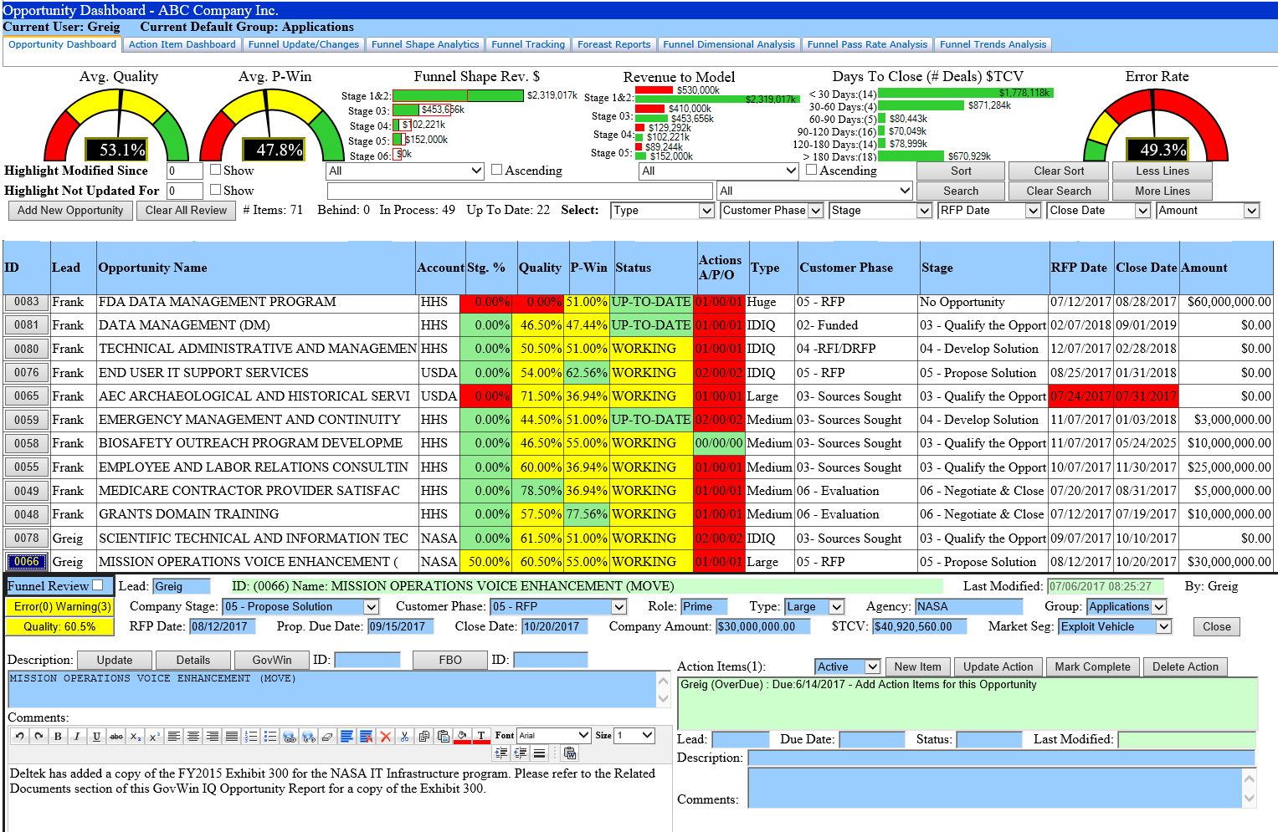

Funnel Shape to Model – Crucial in understanding whether you will meet your goals. This analysis shows the comparison of current funnel characteristics to those that were modeled during the strategic planning process. It considers the numbers of opportunities, type of revenue and will estimate the anticipated number of wins and associated revenue based upon the quality, P-Win and current stage of the opportunities in the pipeline.

All information on opportunities as they go through the lifecycle is stored in an on-line archive. This archive is used to do real time trigonometric analytics of opportunities as they go through the opportunity lifecycle. 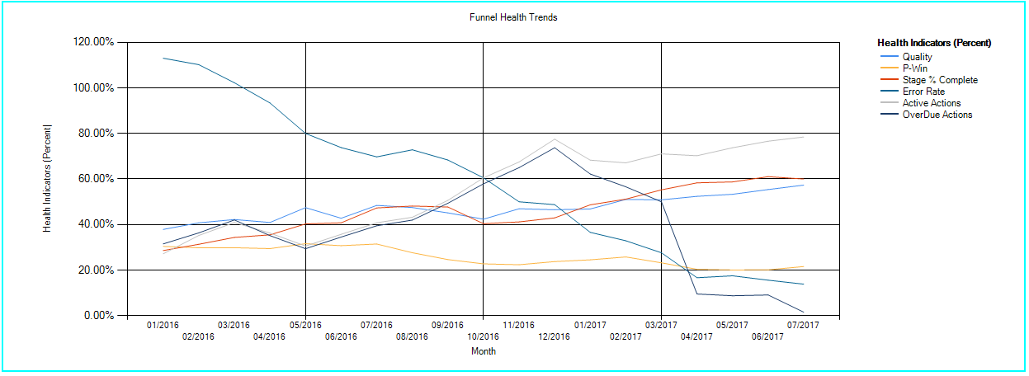The ability to retrieve **Funnel Health Statistics** and trends in real time and check them against performance targets and strategic planning goals, allows for immediate identification of performance shortfalls in particular around BD activities and opportunity quality and enables the ability to address the behaviors or adjust resources as needed to ensure high performance execution and results.

Action Item Review

Allows for the Team review of action Item status, and drives discussion on other actions that may be taken to increase the P-Win on the opportunity. Also identify problem areas where activity is lacking on an opportunity or progress towards specific opportunity timelines is out of synch.

BD Team Performance Characteristics

* Opportunity Additions & Updates
* Opportunity Error Rates
* Number & Types of Opportunities
* Loading Rate (Where you are on the opportunities)
* Action Items (Active, Pending & Over Due)
* Average P-Win & Quality
* (Notice that Win / Loss is a trailing indicator)

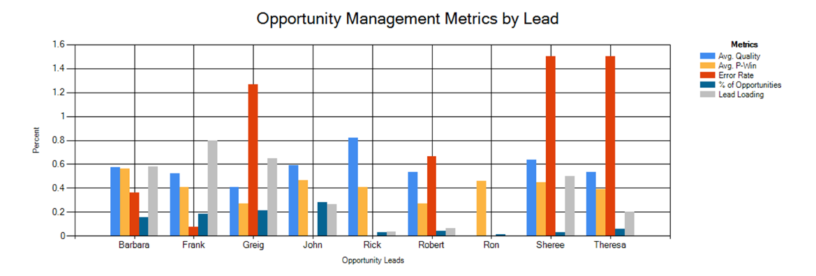Analysis of BD Team Performance is measured in a variety of dimensions from Numbers and Types of opportunities, their stages, average error, quality and P-Win levels, time since an opportunity was added, or updated. Individual BD people can be measured on their B&P Spend to Revenue Won or even their individual cost to revenue won ratio’s over specific selectable timeframes all in real time.

These tools are all web based and available to your team through web browsers as well as through mobile applications on the Apple iOS or Android platforms. The mobile applications can work in an offline mode allowing for updates even when not connected and uploads when network connectivity is restored.

Research on potential partners as well as competitors can be done easily through the vendor research tool obtaining company classification and contract performance information in real time from FDPS and SAM.

## Performance Analysis & Recommendations

Finally, there are tools that take the archived performance information and using various statistical methods analyze how the organization actually performed against the strategic plan. The tool is used to complete an analysis of how BD deliverables such as SWOT Analysis P-Win or Deal Quality relate to the performance results received. This data is used to update your customized configuration parameters as well as strategic planning targets for the next year. Ensuring that over time the activities that are driving the desired results are prioritized as well as more accurate tuning of configuration and modeling parameters to the observed results.

As mentioned earlier all information on opportunities as they go through the lifecycle is stored in an on-line archive. This archive is also used to do overall performance analysis across multiple dimensions of the archived data. We have created an Archive Analysis tool that enables the analysis of the current state of the archive including the following specific tests:

* Disposition Dependency Analysis (Chi-Squares Independence Test)
* Correlation versus Causation
* Spend to Revenue Analysis
* Load Modeler Parameters for comparison
* Disposition status of Deals

These are done on the archive data over specific periods based upon the clients strategic planning calendar as well as targeted periods that may be of interest. A Dependency Analysis can be performed based upon 48 different categories and opportunity states to determine what factors may have positive or negative impacts on observed performance results. Here is a short list of some of those factors

* Disposition Analysis – Final Disposition of the opportunity (won, loss, dropped)
  + By Type and Stage in comparison to model
* Average Spend in Stage by Disposition and Type
* Average Days in Stage by Disposition and Type
* Stage Entry to Disposition Analysis
* PWIN to Disposition Analysis
* Deliverables Completed to Disposition Analysis

Also Cost Analysis to model based upon these dimensions are used to determine what opportunity factors may be driving costs outside of anticipated boundaries.

The table below shows how these parameters can be used to make inferences about opportunity characteristics that can be used to change behavior or to get modeled parameters closer to real world results.

| **Example Archive Attribute Inferences** | | |
| --- | --- | --- |
| **Archive Attribute** | **Relevant Question(s) Answered** | **Sample Inference(s)** |
| Disposition Status | Why are deals dropped?  What is the proportion of deals won, lost, or no bid? | Ratio of Win to Lost deals > 1 Ratio of Lost to No Bid Deals < 1 85% of deals dropped entered at a stage after the recommended stage |
| Archive Date Stage at Disposition Stage at Entry Creation Date | Are deals dropped sooner rather than later? What is the stage at which most deals are dropped? How long (time-wise) does a deal stay before being dropped? | 89% deals dropped prior to Stage 4 |
| Stage at Entry | Is there a correlation between deals dropped and stage at entry? | 100% Huge deals not entering at Stage 1 were dropped No deals that entered at or before the recommended entry stage were dropped |
| Deliverables Completed | Is there a correlation between deals dropped and the completion of deliverables? | Won 92% of deals when all deliverables were completed Won 84% of deals when Blue/Black, Green, and Red Team were completed |
| Market Type  (Vehicle Capture, Bus. Retention, Growth) | Is there a correlation between deals dropped and market type? Are "white space" deals more likely to be dropped? | No white deals dropped after entering Stage 4 |
| Agency | Are deals at specific agencies more likely to be dropped? Or vice versa? | NASA deals were more than twice as likely to get dropped |
| P-Win at Entry | Is there a correlation between deals dropped and P-Win at entry? | 73% of deals dropped had a P-Win < 40% at the time of entry Only 6% deals that were won had a P-Win < 50% at the time of entry |
| P-Win at each Stage | Is there a correlation between deals dropped and the P-Win trend?  Were there any sudden changes/drops or other noticeable patterns? | 87% of deals dropped had either no increase or a decrease in their P-Win from the time of entry to being dropped 91% of deals won had a rising trend in P-Win from entry to submission  83% of deals lost had a decreasing trend in P-Win from entry to submission |

Along with Attribute Inferences, Actual Pass Rate, Opportunity Cost, Opportunity Cycle Times are captured and used to feed back into the following year Strategic Planning process thus completing the BD-in-a-Box Continuous Process improvement loop mentioned at the beginning of this paper.

## Getting Started

All of this information is automated and requires very little initial input to set it up and get going. All information and updates are archived enabling easy review of opportunity status from initial engagement through final disposition.

We can host your information on our secure web site or you it can be hosted on premise behind your firewall and its accounts linked to your corporate active directory enabling ease of integration with SharePoint as well as robust linkage with applications such as Sales Force, Gov Win and others.

## Business Benefits

BD-in-a-Boxtm helps your company ensure that expensive business development and Sales investments yield high performance predictable financial results. It is an approach that ensures you select the right opportunities and have the right staff and processes in place to successfully capture and win targeted opportunities.

It Provides:

* Transparency of Business Development efforts across the organization.
* Facilitate strategic planning & Goals setting as well as forecasting of revenue.
* Maximize utilization of scarce resources for optimal ROI.
* Integration with Federal Business Information sites (FedBizOpps, FPDS, SAM, GovWin and more)
* Expedite proposal development and reduce cost of rework with clear guidance and reusable templates.
* Align proposal development efforts with customer expectations and proven business development and management processes.
* Continuous Process Improvement - Feedback of Critical Performance Data into Strategic Planning and Forecasting Process.
* Accessible through Mobile applications on iOS Apple or Samsung Mobile Devices, and from any web platform in Real-Time.
* Full BD Lifecycle Framework with Opportunity Gate Review Templates and Checklists
* Customizable, Stage Specific, Multi-Dimensional Deal Quality metrics

## Conclusion

BD-in-a-Boxtm Is an affordable, easy to implement easy to use, and Lightweight yet scalable Business development strategic planning, sales operational execution and analysis of business performance results. It is uniquely targeted to drive high quality sales performance through the systematic execution, control and monitoring of BD processes throughout the full BD Lifecycle.